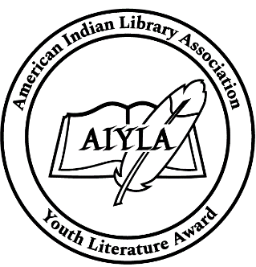
American Indian Youth Literature Award (AIYLA) Price Sheet - BULK

AIYLA Winner (Gold)
AIYLA Honor (Silver)

Code | Description | Unit Price
BULK-1 | 1000 Seals (same seal) | $250
BULK-2 | 2000 Seals (same seal) | $400
BULK-3 | 3000 Seals (same seal) | $550
BULK-4 | 4000 Seals (same seal) | $685
BULK-5 | 5000 Seals (same seal) | $815

For more than 5000 rolls contact aiyla-seals-bulk-orders@ailanet.org

Shipping and Handling
Domestic Shipping and Handling (Based on amount spent):
1-2 rolls: $50
3 rolls: $75
4 rolls: $100
5 rolls: $125

Please contact aiyla-seals-bulk-orders@ailanet.org for international shipping rates.

To order, please send a request to aiyla-seals-bulk-orders@ailanet.org with the quantity you would like to order. We will be in touch with you to complete your order.

** Please allow 2-4 weeks for order to be processed. AILA is not responsible for damaged or lost orders.

Return Policy – All sales are non-refundable, non-returnable and final.

